
K L (Deemed to be) University
DEPARTMENT OF COMPUTER SCIENCE AND INFORMATION TECHNOLOGY
PROJECT REPORT
Resume–Job Matching & Talent Marketplace Engine
Project Report submitted for the partial fulfilment of grade for the course
Data Structures and Algorithms - 3 (25CS2103E)
A.Y. 2026–2027
Submitted by
2520090081 – SAI RAM PRAGNEY MURIKIPUDI
2520090104 – TEJASWIN AMARA
Team Number:32 Section: 10
Under the guidance of
Miss. Chandusha Kanda, Department of Computer Science and Information Technology
Hyderabad-500090, Telangana, India.

K L (Deemed to be) University
DEPARTMENT OF COMPUTER SCIENCE AND INFORMATION TECHNOLOGY
DECLARATION
The Mini Project Report entitled “Resume–Job Matching & Talent Marketplace Engine” is a record of bonafide work of 2520090081 – SAI RAM PRAGNEY MURIKIPUDI and 2520090104 – TEJASWIN AMARA, submitted in partial fulfillment for the award of the B.Tech degree in Computer Science and Information Technology at K L (Deemed to be) University. The work presented in this report is based on the implementation maintained in the project repository and has been prepared for the Data Structures and Algorithms - 3 (25CS2103E) course.
The results and descriptions embodied in this report have been prepared from the project implementation and its documented workflow. The project repository is publicly available at the GitHub repository specified in the References section.

2520090081 – SAI RAM PRAGNEY MURIKIPUDI
2520090104 – TEJASWIN AMARA

K L (Deemed to be) University
DEPARTMENT OF COMPUTER SCIENCE AND INFORMATION TECHNOLOGY
CERTIFICATE
This is to certify that the mini project based report entitled “Resume–Job Matching & Talent Marketplace Engine” is a bonafide work done and submitted by 2520090081 – SAI RAM PRAGNEY MURIKIPUDI and 2520090104 – TEJASWIN AMARA in partial fulfillment of the requirements for the award of the degree of BACHELOR OF TECHNOLOGY in Computer Science and Information Technology, K L (Deemed to be) University, during the academic year 2026–2027.

________________________ | ________________________ | ________________________
Signature of the Supervisor | Signature of the HOD | Signature of the External Examiner

K L (Deemed to be) University
DEPARTMENT OF COMPUTER SCIENCE AND INFORMATION TECHNOLOGY
ACKNOWLEDGEMENT
The successful completion of this project would not have been possible without the timely support, guidance and encouragement received from many people. We express our sincere gratitude to everyone who assisted us directly or indirectly during the development and documentation of the project.
We would like to express our appreciation to our project guide for valuable guidance, technical suggestions and continuous encouragement throughout the project. Their feedback helped us organize the project around the requirements of the Data Structures and Algorithms - 3 course.
We also thank the Department of Computer Science and Information Technology, K L (Deemed to be) University, for providing the academic environment and facilities required to complete this project. Finally, we thank our parents, friends and classmates for their support and cooperation.

2520090081 – SAI RAM PRAGNEY MURIKIPUDI
2520090104 – TEJASWIN AMARA

K L (Deemed to be) University
TABLE OF CONTENTS
S.No. | Contents | Page No.
1. | Abstract | 6
2. | Introduction | 7
3. | Literature Survey | 8
4. | Problem Statement and Objectives | 9
5. | Hardware and Software Requirements | 10
6. | Implementation | 11–12
7. | Results & Discussion | 13–14
8. | Conclusion & Future Scope | 15
9. | References | 16

Note: The page numbers above follow the report's fixed section layout. The final Word document includes the project screenshot in the Results & Discussion section.

1. ABSTRACT
The Resume–Job Matching & Talent Marketplace Engine is a Data Structures and Algorithms - 3 semester project that addresses the problem of efficiently connecting candidates with job opportunities. The system combines a web-based recruiter and candidate workflow with a hand-built algorithmic core for resume parsing, skill extraction, candidate scoring, ranking and marketplace allocation. Instead of relying only on simple keyword matching, the project evaluates candidates using four weighted signals: semantic similarity, skill match, experience and education.
The repository documents a hybrid ATS score in which semantic similarity contributes 40%, skill matching 35%, experience 15% and education 10%. Semantic similarity uses 384-dimensional all-MiniLM-L6-v2 embeddings with cosine similarity and PostgreSQL pgvector storage. Skill matching combines Aho-Corasick multi-pattern matching with Wagner-Fischer fuzzy edit-distance tolerance. The DSA core additionally implements Dinic flow and min-cost max-flow for capacity-constrained allocation, SOS dynamic programming, suffix-array and string-processing techniques, approximation algorithms such as greedy set cover and knapsack FPTAS, randomized sampling, parallel prefix scan, and foundational data structures such as heaps, hash maps and adjacency graphs. citeturn0view0
The project therefore demonstrates how algorithmic techniques can be combined with a practical talent marketplace interface to rank candidates and support recruiter decisions. The implemented workflow includes job creation, resume upload and parsing, ad-hoc matching, candidate leaderboards, marketplace allocation, bottleneck analysis and team building through documented API endpoints. citeturn0view0
Team Name: Resume–Job Matching & Talent Marketplace Engine
Team Members
1. 2520090081 – SAI RAM PRAGNEY MURIKIPUDI
2. 2520090104 – TEJASWIN AMARA

2. INTRODUCTION
Recruitment systems must process large numbers of resumes and job descriptions while still identifying candidates whose skills and qualifications fit a particular role. Manual screening can become time-consuming when recruiters need to compare many candidates against multiple requirements. The Resume–Job Matching & Talent Marketplace Engine approaches this problem as an algorithmic matching and allocation problem rather than as a simple form-based job portal.
The project provides a full-stack workflow. The frontend is implemented using Next.js 14 with React-based interface components. A FastAPI backend written for Python 3.12 exposes asynchronous controllers for jobs, resumes, matching and marketplace operations. PostgreSQL 16 with pgvector provides persistence and vector storage, while SQLAlchemy 2.0 is used for asynchronous database sessions. The repository also documents Docker Compose support for running the multi-service system. citeturn0view0
At the matching layer, a resume can be uploaded as PDF, DOCX or TXT, parsed into usable information and compared with a job requirement. The hybrid score is normalized from four dimensions: 40% semantic similarity, 35% skill match, 15% experience and 10% education. This makes the result more informative than an exact keyword-only comparison because the semantic component can capture related meaning while the skill component still checks explicit requirements. citeturn0view0
The DSA focus is central to the project. The repository describes six algorithmic modules. M1 handles flow-based marketplace allocation; M2 covers dynamic programming and edit distance; M3 implements string-processing algorithms used for ATS extraction; M4 provides approximation algorithms for team formation; M5 covers randomized and parallel techniques; and M6 implements foundational data structures. The project deliberately implements these primitives in its own algorithmic core under a zero-library constraint for several standard data-structure and algorithm libraries. citeturn0view0
The overall workflow is therefore: collect job and candidate information → parse resume content → extract and compare skills → compute semantic and rule-based signals → produce a weighted match score → rank candidates → optionally allocate candidates to jobs or build teams under constraints. The system is designed to demonstrate how classical DSA techniques can support a practical recruitment application.

3. LITERATURE SURVEY
Existing recruitment platforms demonstrate the need for structured search, candidate discovery and matching between skills and job requirements. The following systems were reviewed as related solutions. The comparison is used to position the present project as a DSA-focused implementation that emphasizes algorithmic matching, explainable score components and capacity-constrained talent allocation.
1. LinkedIn Jobs
LinkedIn provides job search, job recommendations and recruiter-facing hiring workflows. Its job discovery experience lets users search by role, location and skills, while its job-search guidance also describes recommendations based on qualifications, interests and activity. This establishes the practical importance of relevance-based job discovery and candidate-job matching.
Reference: https://www.linkedin.com/jobs/
2. Indeed
Indeed is a large job-search platform that supports searching and applying for roles across many categories. Its model illustrates the need to organize job information and make relevant opportunities discoverable to candidates. The proposed project narrows this problem into an algorithmic matching engine with explicit score components.
Reference: https://www.indeed.com/
3. Greenhouse
Greenhouse provides recruiting and applicant-tracking capabilities for organizations. Such systems emphasize structured hiring workflows and candidate management. The present project similarly includes recruiter-oriented operations, but focuses specifically on implementing the matching and marketplace logic using DSA techniques.
Reference: https://www.greenhouse.com/
4. Workday Recruiting
Workday Recruiting integrates recruiting workflows with candidate and job information in an enterprise HR environment. It represents the broader requirement for scalable talent acquisition systems. The project adapts this general problem to a B.Tech-scale implementation using FastAPI, PostgreSQL/pgvector and a hand-built algorithmic core.
Reference: https://www.workday.com/en-us/products/human-capital-management/recruiting.html
5. Lever
Lever combines applicant tracking and recruiting workflows for talent teams. Its approach demonstrates the value of centralizing candidate information and recruitment processes. The project extends the same general domain with explicit algorithmic components for matching, allocation and team formation.
Reference: https://www.lever.co/
6. Resume Job Scoring Engine
Open-source resume-matching projects commonly use semantic similarity, skill scoring and experience-based signals. A representative implementation combines Sentence Transformers, TF-IDF fallback and multi-dimensional scoring. The present project differs in its strong DSA emphasis and its documented use of Aho-Corasick, edit distance, flow algorithms and approximation techniques.
Reference: https://github.com/farhan-439/resume_job_scoring_engine
7. Career-Launch
Career-Launch implements NLP-based resume-job matching using TF-IDF, cosine similarity and explainable skill-gap analysis. It illustrates the usefulness of combining textual similarity with explicit skill overlap. The present project uses a different hybrid formula and adds a broader algorithmic marketplace layer.
Reference: https://github.com/ladHarsh/Career-Launch
8. Intelligent Talent Finder
Intelligent Talent Finder demonstrates semantic search for resumes and jobs using embeddings, vector search and a web API. It reflects the industry trend toward meaning-aware retrieval. The present system also uses dense embeddings and vector storage, while emphasizing hand-built classical algorithms alongside the semantic component.
Reference: https://github.com/the-ab04/Intelligent-Talent-Finder

4. PROBLEM STATEMENT AND OBJECTIVES
Problem Statement: Design an efficient algorithmic system that matches resumes with job requirements and supports scalable candidate ranking and talent allocation.
Problem Description: Recruiters need to compare candidate skills, experience, education and overall profile relevance against jobs while handling many candidates and constrained allocations. A purely manual or keyword-only approach can miss semantic relationships and does not directly solve allocation and team-formation constraints.

Objectives
- Build a practical resume-to-job matching workflow for candidates and recruiters.
- Parse resume documents and extract information required for matching.
- Combine semantic similarity, explicit skill matching, experience and education into a normalized match score.
- Apply string algorithms and dynamic programming techniques to improve skill extraction and profile alignment.
- Use network-flow algorithms for capacity-constrained marketplace allocation.
- Use approximation algorithms for minimum-cost competency team formation.
- Provide recruiter-oriented ranked candidate results and skill-gap information through the web application.
- Demonstrate classical data structures and algorithms in a practical software system.

Key DSA Components
Module | Algorithms / Data Structures | Purpose
M1 – Flow | Dinic, Edmonds-Karp, Min-Cost Max-Flow | Capacity-constrained candidate/job allocation
M2 – DP | SOS DP, Wagner-Fischer / Damerau-Levenshtein, Bitmask TSP | Skill density and profile alignment
M3 – String | Aho-Corasick, KMP, Rabin-Karp, Suffix Array, Kasai LCP | ATS keyword extraction and document parsing
M4 – Approximation | Greedy Set Cover, Knapsack FPTAS, 2-Approx. Vertex Cover | Competency team formation
M5 – Randomised/Parallel | Reservoir Sampling, Universal Hashing, Blelloch Scan | Sampling and parallel processing
M6 – Structures | 4-ary Heap, HashMap, Doubly-Linked List, Adjacency Graph | Foundational data primitives

5. HARDWARE AND SOFTWARE REQUIREMENTS

Hardware Requirements
- Computer/Laptop with a modern multi-core processor
- Minimum 8 GB RAM recommended for running the full development stack
- Adequate disk space for PostgreSQL/pgvector, project dependencies and Docker images
- Internet connection for repository setup, package installation and accessing the deployed/project resources

Software Requirements
- Python 3.12 and FastAPI for the backend API
- Next.js 14, React and pnpm for the frontend
- PostgreSQL 16 with pgvector for persistence and vector similarity storage
- SQLAlchemy 2.0, Alembic and Docker Compose for database sessions, migrations and multi-service execution
- Git/GitHub for source-code management and project versioning
The repository documents both a Docker Compose workflow and local development workflow. The recommended Docker path uses docker compose up --build -d, while local development uses uv for Python dependencies and pnpm for the Next.js application. citeturn0view0

6. IMPLEMENTATION
The implementation is organized into frontend, backend, persistence, parsing/scoring and DSA-core layers. The repository layout identifies API controllers for jobs, resumes, matching and marketplace operations; parsers for PDF, DOCX and text documents; a hybrid ATS scoring engine; PostgreSQL/pgvector persistence; and the Next.js frontend. citeturn0view0

Module 1 – Resume Parsing and Candidate Processing
The system exposes resume upload and raw-text parsing endpoints. Supported uploaded document formats are PDF, DOCX and TXT. Parsed content is then made available to the candidate/matching workflow.
POST /api/v1/resumes/upload
POST /api/v1/resumes/parse-text

Input → Resume document / raw resume text
Process → Validate → Parse → Extract candidate information
Output → CandidateResponse

Module 2 – Hybrid ATS Matching and Candidate Ranking
The matching engine combines four normalized signals. The documented formula gives the largest weight to semantic similarity, followed by explicit skills, experience and education. Skill matching uses Aho-Corasick with fuzzy tolerance based on Wagner-Fischer edit distance.
Score = 100 × (
0.40 × Semantic +
0.35 × Skills +
0.15 × Experience +
0.10 × Education
)

Semantic → cosine similarity of 384-D embeddings
Skills → Aho-Corasick + edit-distance tolerance
Experience→ bounded requirement comparison
Education → ordinal qualification mapping

Module 3 – Marketplace Allocation Using Network Flow
The marketplace module treats candidate/job allocation as a capacity-constrained flow problem. The repository documents Dinic's blocking-flow algorithm, Edmonds-Karp BFS and successive-shortest-path min-cost max-flow, together with residual min-cut analysis.
Candidate nodes → capacity edges → Job nodes
↓
Residual network
↓
Dinic / Min-Cost Max-Flow
↓
Feasible marketplace allocation

Module 4 – Team Builder and Foundational Structures
The team-builder endpoint uses a greedy set-cover approach to form a minimum-cost competency team. The broader M4 module also documents a knapsack FPTAS and a 2-approximation for vertex cover. M6 provides a 4-ary heap, open-chaining hash map, doubly-linked sentinels and an adjacency graph with residual pointers.
POST /api/v1/marketplace/team-builder

Required competencies
↓
Candidate skill sets
↓
Greedy Set Cover
↓
Minimum-cost competency team
The repository also exposes marketplace bottleneck analysis and candidate/job leaderboard functionality, allowing the algorithmic results to be presented through the recruiter workflow. citeturn0view0

7. RESULTS & DISCUSSION
The supplied application screenshot shows the Recruiter Portal of the implemented system. The interface presents active job requisitions on the left and a Candidate Leaderboard on the right. Each candidate card includes a rank, overall match score, score breakdown and a skills analysis showing matched and missing skills.
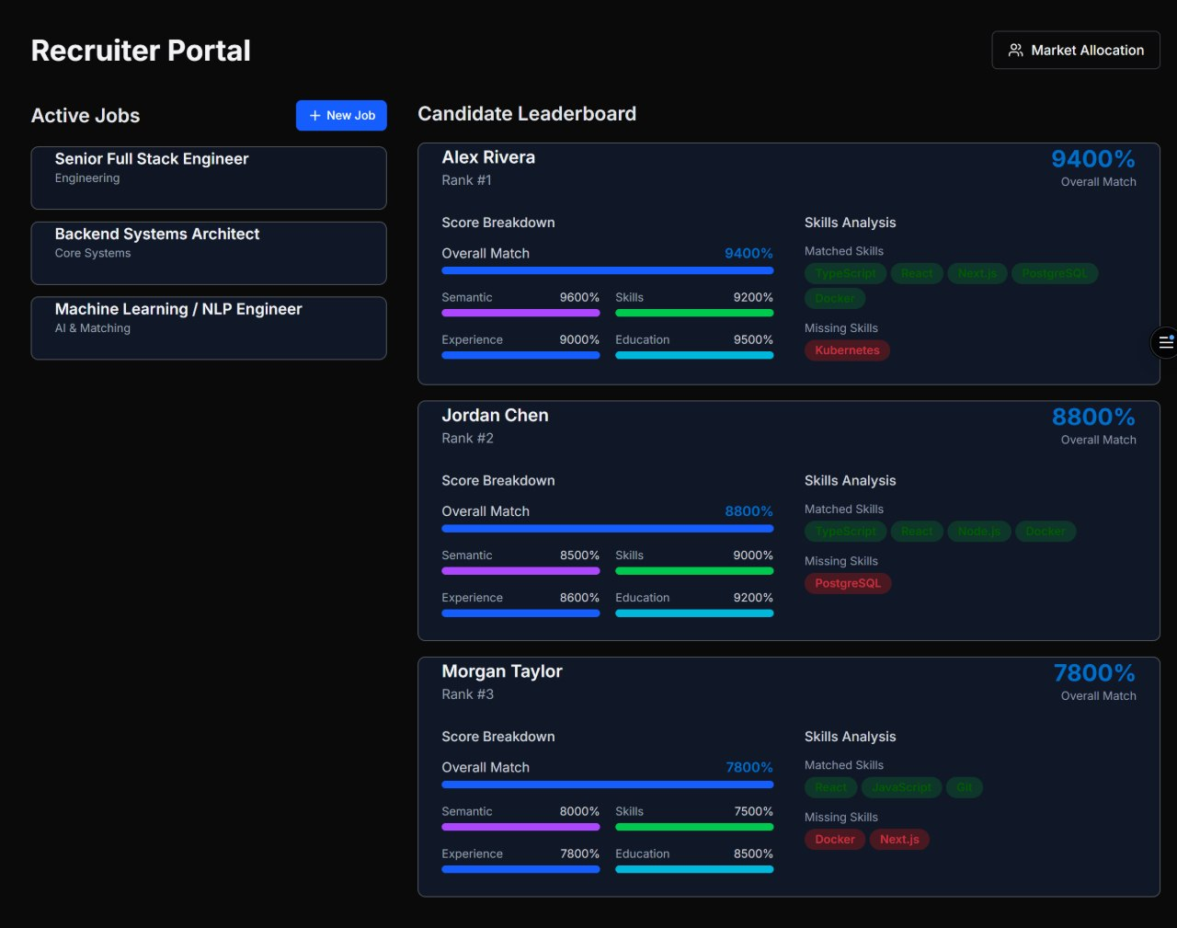
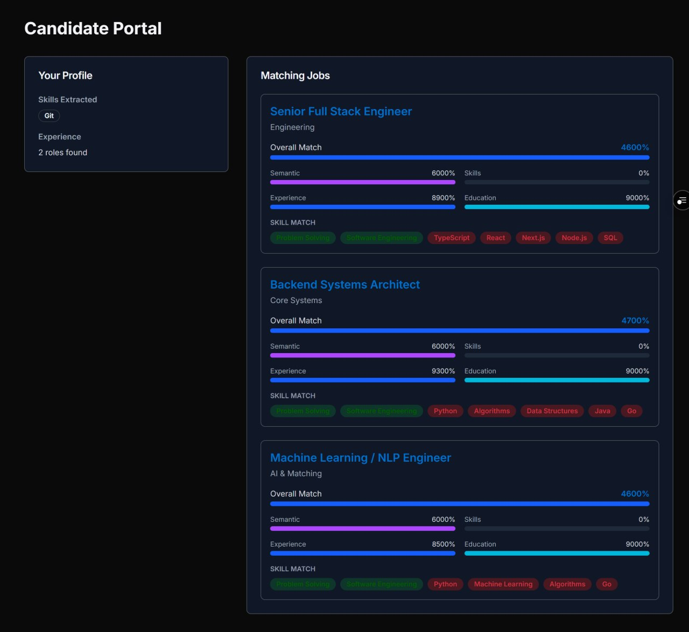Figure 1. Recruiter Portal showing active jobs, candidate ranking, weighted match breakdown, and matched/missing skills.
The screenshot demonstrates the practical output of the matching workflow: recruiters can compare candidates using an overall score and inspect semantic, skills, experience and education components. The skills analysis also distinguishes matched skills from missing skills, making the ranking more interpretable.
The repository documents API support for creating and listing jobs, viewing candidate leaderboards, uploading/parsing resumes, running ad-hoc hybrid matches, allocating candidates to jobs, identifying bottlenecks and building competency teams. It also documents automated verification including backend/algorithmic tests and frontend tests/build checks. citeturn0view0

Observed Output Components
Component | Observed / documented result
Active Jobs | Recruiter portal lists active job requisitions such as Senior Full Stack Engineer, Backend Systems Architect and Machine Learning / NLP Engineer in the supplied screenshot.
Candidate Leaderboard | Candidates are ranked and displayed with an overall match score.
Score Breakdown | Semantic, skills, experience and education scores are shown separately.
Skills Analysis | Matched and missing skills are displayed for each candidate.
Marketplace | Repository documents allocation, bottleneck analysis and team-builder API operations.

8. CONCLUSION & FUTURE SCOPE
The Resume–Job Matching & Talent Marketplace Engine successfully brings together a practical recruitment interface and a DSA-oriented algorithmic core. The system addresses the resume-to-job matching problem by combining semantic similarity with explicit skill matching, experience and education signals, then presenting ranked candidates to recruiters. The repository also extends matching into a marketplace setting through capacity-constrained allocation and competency-based team formation. citeturn0view0
A major contribution of the project is the use of classical data structures and algorithms in a real application scenario. String algorithms support ATS extraction, dynamic programming supports profile alignment, network flow supports allocation, approximation algorithms address difficult optimization problems, and foundational data structures provide efficient primitives. This demonstrates how algorithm selection can improve the efficiency and structure of matching operations instead of treating recruitment as only a user-interface problem.
The system can be further improved by adding more advanced fairness and bias monitoring, richer recruiter feedback loops, improved resume normalization, multilingual document handling, configurable scoring weights, larger-scale benchmarking, explainable match recommendations and stronger deployment/observability capabilities. Future work could also evaluate the matching algorithms on larger real-world datasets and compare their accuracy, latency and scalability under different workloads.

Future Scope
- Introduce configurable recruiter-defined weights for different job categories.
- Expand document parsing and normalization for additional resume formats and languages.
- Add richer explainability for why a candidate received a particular score.
- Evaluate fairness and consistency across candidate groups and job categories.
- Benchmark the algorithmic modules at larger candidate and job volumes.
- Extend the marketplace model with more complex constraints and optimization objectives.

9. REFERENCES
1. Project repository – Resume–Job Matching & Talent Marketplace Engine
https://github.com/tejaswin-amara/Resume_Job_Matching_Talent_Marketplace_Engine
2. LinkedIn Jobs
https://www.linkedin.com/jobs/
3. LinkedIn Job Search Guide
https://www.linkedin.com/jobsearchguide/
4. Indeed – Job Search
https://www.indeed.com/
5. Greenhouse – Recruiting Software
https://www.greenhouse.com/
6. Workday – Recruiting
https://www.workday.com/en-us/products/human-capital-management/recruiting.html
7. Lever – Recruiting Platform
https://www.lever.co/
8. Resume Job Scoring Engine – GitHub
https://github.com/farhan-439/resume_job_scoring_engine
9. Career-Launch – GitHub
https://github.com/ladHarsh/Career-Launch
10. Intelligent Talent Finder – GitHub
https://github.com/the-ab04/Intelligent-Talent-Finder
Repository-derived technical details in this report are based on the project README and documented repository structure, including its architecture, algorithmic modules, scoring formula, API endpoints and implementation layout. citeturn0view0
— End of Report —

